Corrected Diagrams for the University Timetable Optimization and Management System
Cleaned for proper system boundaries, actor placement, and safer UML/process-model representation

1. Incremental Process Model Diagram
This diagram keeps Incremental as the primary lifecycle. Prototyping is shown only as an early validation technique inside early increments, which is the safer academic representation for your project.
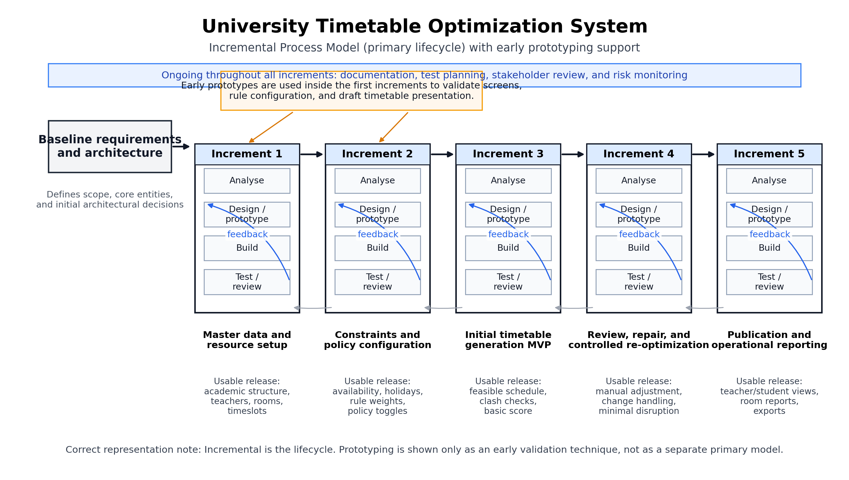
Diagram 1. Incremental Process Model

2. System Context Diagram
This is a context diagram, so the system is shown as one black-box boundary with external actors around it. It intentionally does not use use-case ovals or UML include/extend relations.
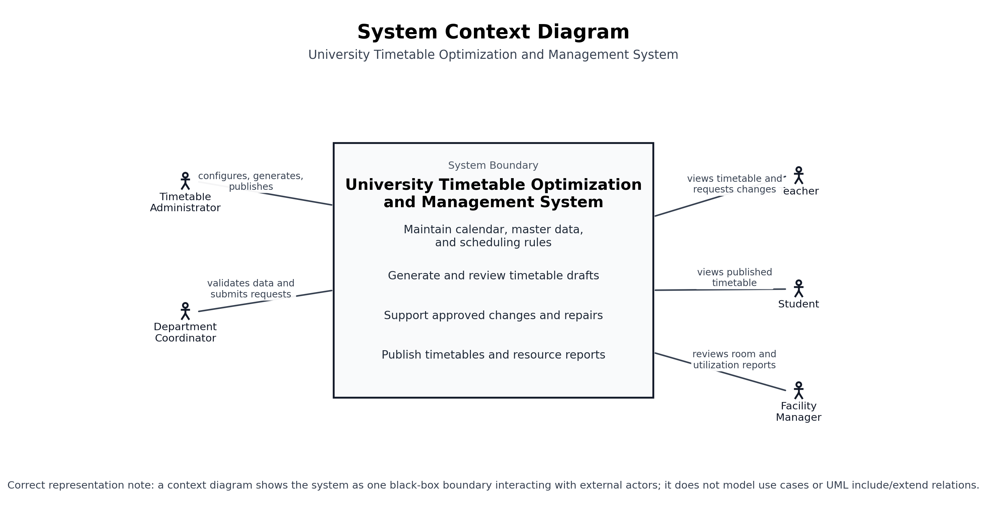
Diagram 2. System Context Diagram

3. High-Level UML Use Case Diagram
This use case diagram uses one clear system boundary, external actors outside the boundary, and actor-use case associations only. It avoids questionable include/extend links where the relationship is really a business dependency rather than reusable use-case behavior.
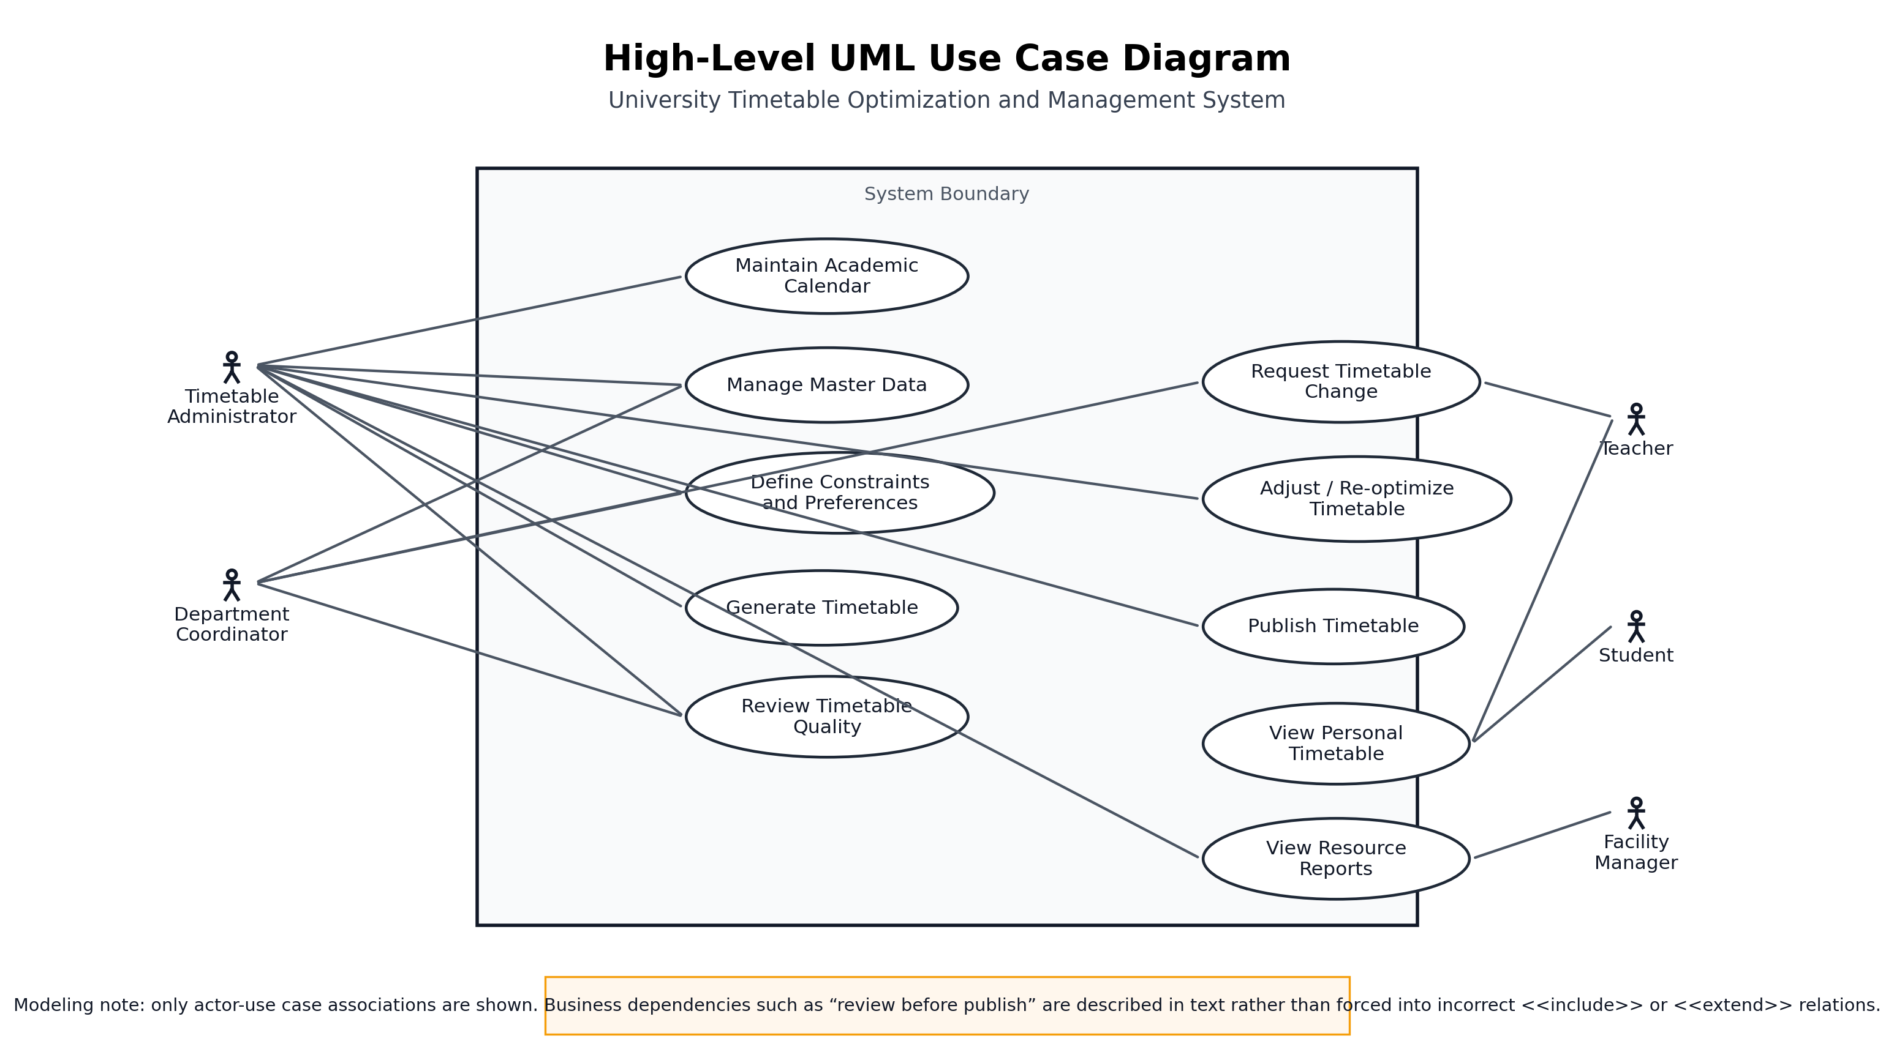
Diagram 3. High-Level UML Use Case Diagram

